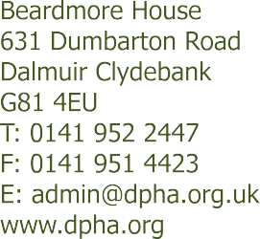

Dear Applicant

POST TITLE: SUPPORT WORKER

Thank you for expressing an interest in the above post. Please find enclosed an application pack containing the following:

- Role Profile
- Application Form
- Equal Opportunities Monitoring Form
- Guidance Notes
- Summary of Terms and Conditions
- Employee Privacy Notice

When submitting your completed application, please return the following documentation:

- Your completed Application Form
- Your completed Equal Opportunities Monitoring form

Please do not enclose your Curriculum Vitae.

Once completed your forms should be returned by email to recruitment@dpha.org.uk no later than Friday 06 August 2021. Please note that applications returned after this time will not be considered.

If you are submitting a hard copy of the application pack, please address For the Attention of: Corporate Services / Recruitment.

Thank you for your interest in this post, we look forward to receiving your application.

Yours sincerely

Pauline McDaid
Corporate Services and HR Adviser

Promoting Equal Opportunities
Scottish Charity No. SC033471
Co-operative and Community Benefit Societies Act 2014 Reg No. 1917 R(S) Scottish Housing Regulator No. HAL 98 Scottish Property Factor No. PF000397

