Board of Management Application Form

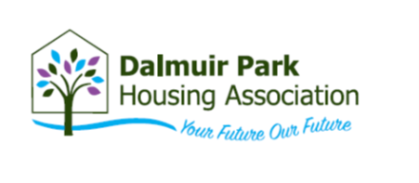

Please return completed to: Anne E Smith, Corporate Services Officer. admin@dpha.org.uk

Personal Details

Name:
Home Address:

Date of Birth:
Email Address:
Mobil Tel No:
Home Tel No:
Work Tel No:

Current or most recent employment:

Name & Address of  Employer | From  Month/Year | To  Month/Year | Position Held and Main Duties

Past employment

Name & Address of  Previous Employer(s) | From  Month/Year | To  Month/Year | Position Held and Main Duties

Qualifications, Training and Professional Membership

Name of Awarding Body | Qualifications, Training, Membership of Professional Institution etc

Voluntary Experience

Organisation | Role | Dates

Please describe how your experience, skills and knowledge would enable you to meet the requirements of being a Board Member. This does not have to be from paid work, but can be from other experience or voluntary work.

SKILLS AND EXPERIENCE YOU COULD BRING AS A MANAGEMENT COMMITTEE MEMBER

In particular:

- Financial and Treasury Management
- Legal and Regulatory Affairs
- Organisational Culture and Staff Wellbeing
- Health and Safety in Housing Compliance
- Asset Management and Sustainability

Skills, Knowledge and Experience | How you meet this requirement

Please tell us the reason(s) for wishing to serve on our Management Committee

Board meetings are held in the evening and online, with the occasional day events and in-person meetings. How would this fit in with your professional and personal commitments?

During the lighter evenings, we will revert to in-person meetings, with a hybrid option available. Is this suitable to you?

Yes No

Please specify any potential conflicts of interest you may have if you were to become a Board Member: (for example, are you related to any staff member, member of the Management Board to the best of your knowledge and/or do you have any relatives in the area who may be connected to one of our contractors, rents one of our properties, etc.):

Signature: Date:

Embracing Equality, Diversity and promoting Inclusion at Dalmuir Park Housing.

Dalmuir Park Housing Association is committed to fostering an environment that celebrates and promotes equality, diversity, and inclusion for all our tenants and service users. We believe in valuing and empowering everyone, regardless of their background. We provide equal opportunities, promote fair treatment and strive to eliminate discrimination. Our diverse team reflects the communities we serve, and we actively engage with our community to understand their needs. Through inclusive practices and a culture that celebrates diversity, we aim to create a vibrant community where everyone can thrive.

Please return completed application form to Anne E Smith, Corporate Services Officer, Dalmuir Park Housing Association, Beardmore House, 631 Dumbarton Road, Dalmuir, Clydebank, G81 4EU or email admin@dpha.org.uk

